|  |
| --- |
| **STUDENT NAME** |
| Alley Chaggar |

**LAB #15**

BEFORE WE START 2

ACTIVITY 1 2

ACTIVITY 2 5

ACTIVITY 3 10

ACTIVITY 4 13

ACTIVITY 5 17

# BEFORE WE START

1. Double – click on the Blender icon on your desktop.
2. Close the tutorials windows.

# ACTIVITY 1

## BASIC ANIMATION, FRAMES AND KEYFRAMES

This tutorial demonstrates the basics of Animation, Frames and Keyframe. A Frame is an image forwarded to an output device (e.g. a screen). A Keyframe is a Frame that defines a milestone to the movement of an object. A basic animation should, at least, contain a starting and an ending Keyframe.

Follow the steps below:

1. Click on the Cube, in the scene.
2. Click File 🡪 Open the Mug.blend file from the Lab #15 Support Files.
3. If there is a Plane, under the Mug, click on it and press Delete.
4. Click on the Animation tab.  
     
   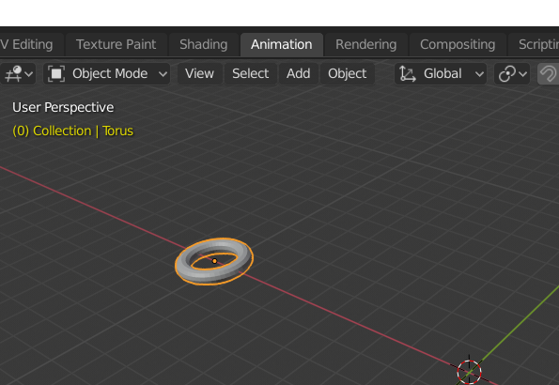
5. Position the Mug to the center of the axes.
6. Click on the Mug and select it.
7. Press G and without moving the cursor, press X once.
8. Then, move the Mug over the X axis, in a position that is barely rendered by the camera.
9. In the Timeline, make sure that the Selector is at Frame 0.
10. Press I and then Location.
11. The Timeline should look like this:  
      
    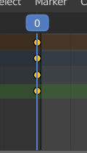
12. Now, click on the Mug, press G and then X, once.
13. Move the Mug along the X axis, until the edge of the camera’s frustrum.
    1. Then click on the Selector and drag it to Frame 24.
14. Click Key 🡪 Insert Keyframe 🡪 All Channels.
15. Move the Selector back to Frame 0.

|  |
| --- |
| **TASK 1.1:**  What do you see? What is happening? Answer the questions in the cell below. |
| The mug is goes back to the position it was in the beginning. |

1. Move the Selector back to Frame 20.
2. In the Scene, make sure, that the Cursor is placed to the center of the axes.
3. Click Add 🡪 Mesh 🡪 Plane.
4. Press S and scale the Plane to cover the viewport of the camera.
5. Click on the Mug, in the scene and then press G and Z.
6. Move the cube along the Z Axis and put it on the surface of the plane.
7. Move the cube to Frame 0.
8. Press Space.

|  |
| --- |
| **TASK 1.2:**  What do you see? What is happening? Answer the questions in the cell below. |
| There is no cube in the scene but the mug goes back to how it was before. |

1. Press Ctrl-Z and return the Mug to its original location.
2. Select the 0 Frame (your Keyframe).
3. Press G, Z and then 1.
4. Press I 🡪 Location.
5. Try to drag the Selector toward Frame 24.

|  |
| --- |
| **TASK 1.3:**  What do you see? What is happening? Answer the questions in the cell below. |
| The mug moves to the right. |

1. Expand the Object Transform menu.
2. Select the Z Location Frame (the small orange circle) and press Shift+D.
3. Then drag them over the second location (Frame 24).
4. Press Space.

|  |
| --- |
| **TASK 1.4:**  What do you see? What is happening? Answer the questions in the cell below. |
| All frames move equally with each other and pressing space drops them all together. |

1. Select the all the Z and Y Location keyframes and press Delete 🡪 Delete Keyframe.

# ACTIVITY 2

## RECORDING ANIMATIONS

The next step on Animation is to record and keep the animated objects. This tutorial demonstrates how to record and export the animated objects.

Follow the steps below:

1. Click on the Record Button, at the Animation Toolbar.  
     
   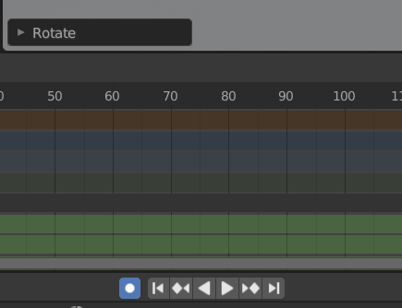
2. Click on the Mug and press R.
3. Left-Click on the Mug (do not rotate it at all) and display the Rotation Keyframes.
4. Move the Selector to Frame 24.
5. Make sure, that the Mug is selected and press N.
6. Under the Transform tab, set the Rotation 🡪 Z axis to 360.

|  |
| --- |
| **TASK 2.1:**  Have you recorded anything? Answer the question in the cell below. |
| Doesn’t do anything because it rotated in a full circle. |

1. Select the Mug.
2. Move the cursor over the Mug and press R.
3. Just click on the Mug (do not rotate) with the Rotation tool selected.

|  |
| --- |
| **TASK 2.2:**  Have you recorded anything? Answer the question in the cell below. |
| The rotating point is beside the mug. |

1. Set the Ending Frame to 50, as shown below:  
     
   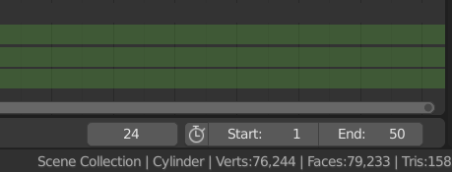
2. Move the Selector to the 50 Frames
3. Click on the Mug, press G and X.
4. Move the Mug, approximately, half-way from the distance between Frame 0 and Frame 24 location.
5. Press S and Scale the Mug a bit.
6. Move the selector to Frame 0.
7. Press Space.

Once you complete the previous steps:

|  |
| --- |
| **TASK 2.3:**  Take a screenshot of the object and while it is moving and paste it below: |
|  |

1. Click on the Record button and deactivate it.
2. Press B and select all the Scale keyframes.
3. Press Delete 🡪 Delete Keyframes.
4. Place the Selector to Frame 50.
5. Select the Mug and press S.
6. Scale to a factor of 2 to 3.
7. Move the Selector to Frame 0.
8. Press Space.

Once you complete the previous steps:

|  |
| --- |
| **TASK 2.4:**  Take a screenshot of the object and while it is moving and paste it below: |
|  |

|  |
| --- |
| **TASK 2.5:**  Describe its Animation and how it scales. Provide the description in the cell below. |
| The animation is like all the rest but this time the scaling stays the same then in only on keyframe |

1. Press Ctrl+S and close Blender.

# ACTIVITY 3

## CHARACTER ANIMATION (SINGLE)

One of the most challenging tasks is the animation of a character. The character’s parts should be moved, positioned, rotated and keyframed such as they create a normal movement flow. This tutorial demonstrates how to animate a humanoid character in a single animation.

Follow the steps below:

1. Start Blender and press File 🡪 Open.
2. Open the Kido.blend file in Blender.
3. Save the Kido.blend file as KidoRiggedSingleAnim.blend.
4. Click Add 🡪 Mesh –> Plane.
5. Position the plane under the feet of the character.
6. Scale the plane as needed, creating a spacious floor.
7. Click on the Animation tab.
8. Switch to Pose Mode.
9. Set the Selector to 0 and set the end Frame to 40.
10. Move the Feet apart resembling a walking stance.  
      
    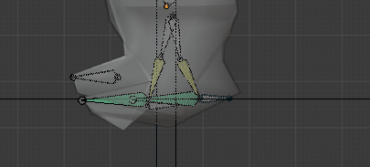
11. Move the arms toward the opposite directions.
12. Use a combination of R and Y to rotate.
13. Press A (selecting all the armature) and I.
14. Then select LockRot.
15. On the Header, press Ctrl+C.
16. Click on the 20 Frames.
17. In the Header, press Shift+Ctrl+V.
18. Press A.
19. Press I and then, LoctRot.
20. On the Header, click on the 0 Frame (the first keyframe).
21. Press Ctrl+C.
22. Click on the 40 Frames.
23. Press Shift+Ctrl+V.
24. Make sure that the whole rig is selected.
25. Press I and All Channels.
26. Check the Animations moving the Selector.

|  |
| --- |
| **TASK 3.1:**  Take a screenshot of the model and paste it below: |
|    * **This isn’t my character because my character wasn’t connecting the mesh with its bones properly, so I used the kid in the last lab (lab14).** |

Close the Kido file.

# ACTIVITY 4

## MULTIPLE ANIMATIONS – EXPORTING

So far, we have added only one animation to our character. What if we need to add multiple animations? The multiple animations are called Actions. We open the Dope Sheet and every time we add a new Action and after its creation, we have to save it pressing F (or saving to the Fake User).

Follow the steps below:

1. Open the Kido.blend file in Blender.
2. Save the new file as KidoRiggedMultiAnim.blend.
3. Click on the Animation tab.
4. Switch to Pose Mode.
5. In the Dope Sheet set the length of the Animations from 0 to 40.
6. In the Dope Sheet click on the New Action Button.  
     
   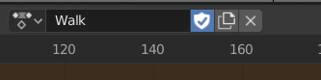
7. Name the new action Walk.
8. Open the Dope Sheet and place to Selector to Frame 0.
9. Move the legs and arms of the character to form a walking stance.
10. Press A.
11. Press I and then LocRot.
12. Expand the Dope Sheet Header to check if the animations are saved.
13. Move the Selector to the 20 Frames.
14. Move the character to the next walking pose (opposite directions).
15. Press A.
16. Press I 🡪 LocRot.
17. Select All Channels.
18. Move the selector left and right and check if the animations is working.
19. Place to Selector to Frame 0 and press Ctrl+C.
20. Click on Frame 40 and press Shift+Ctrl+V.
21. Press the Fake User button or F (make sure it is selected).
22. Press the New Action Button.
23. Name the new action Jump.
24. Press B and select all the Keyframes delete
25. Press Alt+G and Alt+R to reset any transformations of such kind.
26. Create a Jump animation as before repeating steps 8 – 21.
27. Press the F key before switching to any new animation.
28. Check the NLA Properties at Compositor for the new animations.  
      
    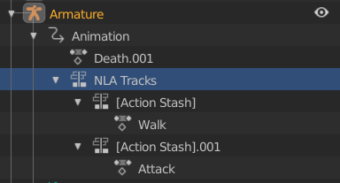
29. Repeat steps 8 – 21 for a Death Animation.
30. Repeat steps 8 – 21 for an Attack Animation.
31. Click File 🡪 Save.
32. Switch to Layout mode.
33. Hide the Control bones pressing H.
34. Select both the Armature and the Mesh.
35. Click File 🡪 Export 🡪 FBX.
36. Select the Selected Objects option.
37. Press Export FBX.

Once you complete the previous steps:

|  |
| --- |
| **TASK 4.1:**  Take a screenshot of the model and paste it below: |
|  |

|  |
| --- |
| **TASK 4.2:**  Generate the Kido model and add it to the submission folder. |
| upload iconIn the LMS, add the file to the assignment Lab #15 submission folder. You can submit multiple files at a time. |

# ACTIVITY 5

## IMPORTING TO UNITY

The last step of the pipeline is the importation to the Game Engine (Unity). The process is simple, but we should not forget to setup the import settings for the Rig and the Animations. This tutorial demonstrates how to create such a character in Unity.

Follow the steps below:

1. Start the Unity Editor and create a new project with the name 3DCharacterAnim.
2. Under the Project tab, create a new folder and name it Character.
3. Drag and drop the character (Kido) in the Character folder.
4. Make sure that all the components are imported, expanding the asset.
5. Under the Inspector, setup the Model tab, as shown below:  
     
   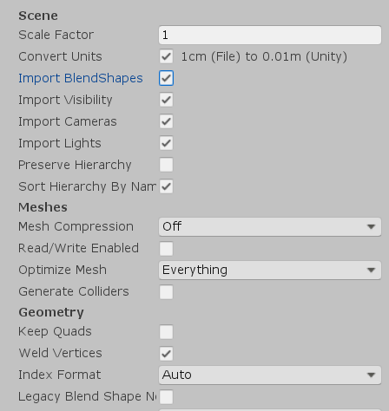
6. Click on the Rig tab and configure its options as shown below:  
     
   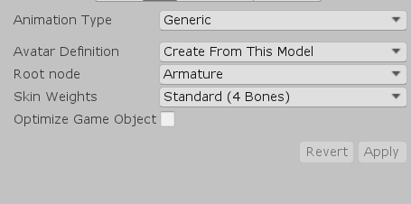
7. Click on the Animations tab and if you have followed the previous tutorial correctly, you should see the animations list.
8. Set the settings as shown below:  
     
   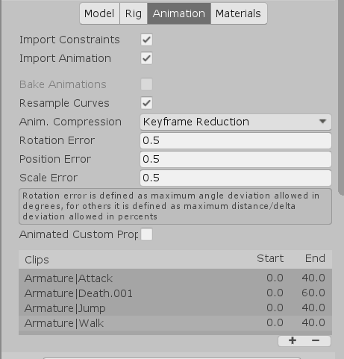
9. Scroll down and click on the walk animation.
10. Select the Loop Time option (the animation should be continuously repeated).
11. Select all the Bake options underneath.
12. Right-Click inside the character folder and Create 🡪 Animator Controller.
13. Name the new file KidoAnimController.
14. Double click on the KidoAnimController file and open the Animator.
15. Under the Animator press Right-click 🡪 Create State 🡪 Empty.
16. Click on the Empty State and under the Inspector change its name to Walk.
17. Click on the Motion selection button and pick the Walk animation.
18. Select the Foot IK option.
19. Drag and Drop the Kido model to the Scene View.
20. Select the Kido and under the Inspector 🡪 Animator, set the Controller property to the KidoAnimatorController file.
21. Press the Play button and check if the animation works.
22. Stop the Game.
23. Add a Player Controller Component.
24. Make sure that the Center of the character is actually the center of the model and the Radius and Weight are in place.
25. Add a Rigidbody (set to Kinematic) and a Capsule Collider to your character.
26. Double click on the Animator again.
27. Click on the character and expand it.
28. Drag and drop the Jump Animation in the Animator.
29. Change its name to Jump.
30. Add a new Integer Parameter in the Animator clicking the + symbol.
31. Name the parameter **condition** and set it to 0.
32. Start the Game and change the value from 0 to 1 and check if the animation changes.

Once you complete the previous steps:

|  |
| --- |
| **TASK 5.1:**  Take a screenshot of the Unity Game View while playing the game when the condition is set to 0 and paste it below: |
|  |

|  |
| --- |
| ADVANCED Create 5 different Animations in Blender (Idle, Walk, Run, Attack, Death) and develop a script that controls the animations, the transitions and the movement of the character. |

FINAL STEP: Save this document as a PDF. Upload the PDF to the Lab #15 submission folder.